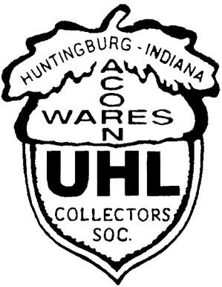

Visit us on the Web @

www.uhlcollectors.org
Russell A. Uhls

6718 Waverhill Dr. Indianapolis, IN 46217
Hm.: 317-851-8222
Work: 317-570-5830 ext. 205
Work Cell: 574-527-8994
Presorted Standard U.S. Postage Paid
Indianapolis, IN Permit

2010 Uhl Collectors’ Society
Annual Convention
Was a Great Time!!!

Thanks to all who participated
Look for friends pictures inside!!!

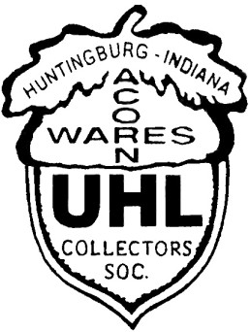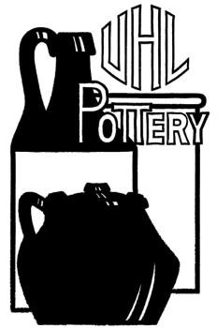Uhl Collectors Society

July 2010

**********************************************

From The President’s Desk

Presidents Plan for Oil Spill recovery.

Everyone has read about the oil leak in the Gulf of Mexico. I think that the Uhl plant should open back up and immediately begin making oil jugs again. In addition, they could produce oil lamps to burn the oil in. This would provide people with jobs, capture the oil and use it. Another possibility would be to remake the ink wells, fill them with a little oil from the Gulf and
sell them as oil well souvenirs. Les

********************************************************************************

From the Press Secretary

To say the least, a good time was had by all this year! I’ll keep it short & sweet. Enjoy the pictures within these
pages, from the convention & start thinking about next year! Russ

We Are Now On Facebook!

Please join us in growing our new Facebook Group & Non Profit Organization Pages!
Just log on to your account and search “UHL Pottery”.
You will see the LOGO on both pages.

What’s Inside
Page 2: 2010 Convention Auction Items & Purchase Prices
Page 3 Through 7: Convention Pictures

2010 Auction Items & Sale Prices

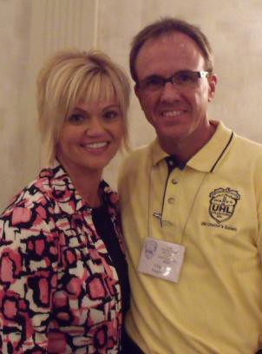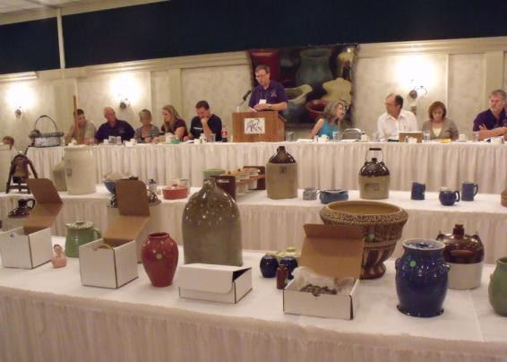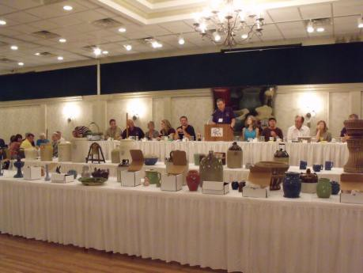
1) Pink dinner set of 9 $45.00
2) 2010 Green & White Comm. $55.00
3) Set of 6 Tan Mugs $35.00
4) 2 Sets, Salt & Peppers/Tan & Yellow $90.00
5) Black Scotty Dog $100.00
6) 2010 Blue Comm. $125.00
7) Blue Candle Holder $100.00
8) Blue Oil Lamp $310.00
9) #156 Brindle Vase $45.00
10) 2010 Brindle Comm. $55.00
11) Brown Donkey Planter $275.00
12) 2009 Comm. $32.50
13) Large Purple Piggy Bank $530.00
14) Green Jane Platter $200.00
15) 2010 Blue Sponge Comm. $80.00
16) Pink Chicken $875.00
17) Green Mini Pitcher $22.50
18) 2010 Green Comm. $70.00
19) Pink Hand Turned Vase $52.50
20) 2009 Brown Comm. $30.00
21) Brown Mini Demijohn $52.50
22) 2009 Brown Comm. $20.00
23) Blue Hand Turned Cookie Jar $540.00
24) Green Thieves Jar (Double Marked) $325.00
25) 2009 Brown Comm. $25.00
26) Brown & White Merry Christmas
Wreath Jug $325.00
27) 5 Gallon Shoulder Jug $65.00
28) #7 Blue Bowl with Advertising $110.00
29) 7 Gallon Crock $860.00
30) 2009 Brown Comm. $25.00
31) Brown Jardinière & Stand $390.00
32) Blue Globe Pitcher $35.00
33) Tall Blue Grape Stein $40.00
34) White Kansas City Piggy Bank, Small $50.00
35) Blue 2nd Size Lincoln Pitcher $115.00

36) Smith & Claxton Advertising Jug $565.00
37) Blue #122 Tulip Bowl & Book $65.00
38) 1998 Comm. $80.00
39) 3 Gallon Evansville Jug $150.00
40) White Salad Bar Set $55.00
41) Green Hand Turned Jar $250.00
42) Pink #151 Casserole
43) 1990 Tan (Special) Comm. $55.00
44) 1996 White With Blue Stripe
(Special) Comm.
45) 1994 Comm. $60.00
46) Blue & White Home Sweet Home Mug $285.00
47) 2 Blue Bowls / #10 & #13 $90.00
48) 5 Gallon Churn $130.00
49) Tan Jug With W.E. Tipton Advertising $275.00
50) Liberty Bell Lamp $80.00
51) Tan Greetings From Uhl Pottery Prunella $80.00
52) 7 Gallon Crock $950.00
53) 5 Gal. White Ice Water Cooler $290.00
54) 3 Gallon Evansville Churn $160.00
55) White Chamber Pot $65.00
56) Field & Sons Advertising Jug $110.00
57) 5 Piece Miniature Collection $55.00
58) Blue Platter $90.00
59) Blue Flower Frog Vase $52.50
60) Tan Harvest Jug $90.00
61) Tan Porch Pot $100.00
62) Blue Salt & Pepper $55.00
63) Small Yellow Bowl $27.50
64) 3 Gallon Evansville Shoulder Jug $220.00
65) 3 Gallon Acorn Jug $70.00
66) Green Squat Pitcher With Lid $300.00
67) 1 Gallon Jug $40.00
68) Blue Sponge Pitcher $240.00
69) #168 Blue Bud Vase $30.00
70) Blue Frog Vase $45.00

